LTER EML Microsoft Excel Metadata Template Documentation
(xls_eml_01.xls)

The metadata fields listed in the LTER EML Microsoft Excel metadata template are in compliance with the Ecological Metadata Language (EML) 2.0.1 Standards and Formats (http://knb.ecoinformatics.org/software/eml/ ) and the LTER EML Best Practices Tier 5 EXCEPT for the "Constraint' Element (September, 2004).

The LTER EML Microsoft Excel metadata template was created to facilitate the capture of EML metadata. The ultimate goal for Information Managers is to produce a valid EML document which could be submitted to Metacat, a flexible XML database. There are 3 steps necessary in producing a valid EML document when using the EML Microsoft Excel metadata template:

Step 1: Capture EML (Tier 5, Except for the Constraint Element) metadata using the
EML Excel metadata template.

Step 2: Load completed LTER EML Microsoft Excel metadata template file into the
Perl EML converter program.

Step 3: By default, the Perl program will automatically validate the new EML file.
It is suggested that the user re-validate the converted EML (xml) file by loading
or pasting file into the KNB EML 2.0.1 validation service at http://knb.ecoinformatics.org/emlparser/index.html or into an XML editor like XMLSpy or Stylus Studio to validate document. Note: if an XML editor is used for validation, the user MAY have to have a copy of the EML schema stored locally and the eml.xsd path at the top of the generated EML document will have to be changed to the local path, as well as, the stmml.xsd path at the bottom of the document in the additional metadata section (i.e.xsi:schemaLocation="eml://ecoinformatics.org/eml-2.0.1 eml.xsd and xsi:schemaLocation="http://www.xml-cml.org/schema/stmml stmml.xsd).

Step 4: Once EML (xml) document is validated (no errors) then the document can be
submitted to Metacat or stored in a folder for Metacat harvest.

Basic Instructions

- Please fill in all blank, underlined rows as completely as possible unless directed otherwise by notes in the field. In some cases, field may not be applicable for datasets, such as 'Dataset Creator Organization Name'. Each metadata field has an accompanying comment box directing users as to what type of information should be entered.

- Separate multiple entries using vertical line delimiters (|). (Applies to the Street Address and Research Project Temporal Coverage fields).

- Please do NOT insert or delete rows from the template (long entries will wrap within cells, except as noted below) as the Perl converter program will not work. Note that extremely long entries may not be completely displayed even when the cell is enlarged, but the full contents will be retained and will export properly.

- EML tags used for metadata field are listed in Column A of same metadata field row.

- Optional Metadata fields are magenta.

- Blue Metadata fields will most likely be completed by the Information Manager.

- If a row background is light blue, please enter multiple first names, addresses, keywords, etc. in new columns. Please note: Creator, Contact, Geographic description, Data Entity Taxon, and Research Project personnel sections must include all information for one person, taxon, or location in the SAME column.

- Move the mouse pointer over a field name to display instructions and comments.
Click +/- icon in column 1 to expand or hide EML category (i.e. Dataset Creator).

- Once the EML metadata template is complete, save the file and then load the completed metadata file into the Perl EML converter program. The metadata will be converted into a valid EML xml document. Please read the Perl documentation for instructions on how to launch and use the program.

Description of Template Worksheets

I. General Metadata Worksheet

A. LTER Dataset Information
General dataset metadata including Dataset Creator, Dataset Coverage,
Dataset Distribution, Dataset Associated Party, Dataset Contact, Dataset
Publisher, Dataset Metadata Provider, Dataset Access, Dataset Methods,
Dataset Quality Control and Dataset maintenance.

B. LTER Dataset Table Information
General Entity and Attribute metadata such as Entity Name, Entity Description
and Number of Data Records. The detailed Attribute information is entered
separately in the ‘DataTable’ worksheet.

C. LTER Research Project Information
A link is followed to a general research project information worksheet labeled
‘ResearchProjects’.

D. Additional Metadata - Dataset and Project
Additional metadata such as Dataset Research Type, Dataset Submission Date,
and Dataset Purpose can be entered in this section. These metadata fields are
NOT part of the required EML nor were they listed in the LTER EML Best Practices document. Users may modify this section as needed but MUST be
sure to make the appropriate changes to BOTH column A and column B.

II. MethodsCitation Worksheet

Enter methods citation information beginning with Dataset Methods Citation Number 5.
The title, author’s name, and publication date are common to ALL types of citations and
are found in the first section of the citation block. On Row 12, the user is prompted to
‘SELECT A CITATION TYPE’ and once the choice is made, the appreciate citation fields
will appear in the following rows. Remember that the citation information is entered as a
block so if there are multiple citations, the next citation entry would occur under Dataset
Methods Citation Number 28. Do NOT change the citation numbers (citation number = row number) for any reason as the Perl program will offset the entered information. If
additional citation blocks are needed, copy a complete section and paste at the bottom
of the worksheet. The citation IDs must be entered in ROW 113 of the General Metadata Worksheet.

III. MethodsProtocol Worksheet

Enter methods protocol information beginning with Dataset Methods Protocol Number 5.
Remember that the protocol information is entered as a block so if there are multiple protocols, the next protocol entry would occur under Dataset Methods Protocol Number 28. Do NOT change the protocol numbers (protocol number = row number) for any reason as the Perl program will offset the entered information. If additional protocol blocks are needed, copy a complete section and paste at the bottom of the worksheet. The protocol IDs must be entered in ROW 114 of the General Metadata Worksheet.

IV. ResearchProjects Worksheet

Enter research project information beginning with Research Project Number 5.
Remember that the project information is entered as a block so if there are multiple projects, the next project entry would occur under Research Project Number 28. Do NOT change the project numbers (project number = row number) for any reason as the Perl program will offset the entered information. If additional project blocks are needed, copy a complete section and paste at the bottom of the worksheet. The project IDs must be entered in ROW 146 of the General Metadata Worksheet.

V. DataTable Worksheet

Detailed data attribute information and data values are entered in the DataTable worksheet.

- Do NOT fill out or delete the custom unit section (red text, yellow cells). These cells will be filled out automatically (from the 'Units' worksheet) when you select a value from the 'Units' cell dropdown list.

- Descriptions of each header field are listed in the cell comments (hover the mouse pointer over the field name to view)

- Make sure the column formatting is appropriate for your data - values will be export 'as is' so undisplayed digits will be lost.

- Fill out the header section (cyan cells) for each data column as completely as possible. Fields in bold are required.

- Paste or enter your data values into the 'Values' section (white cells), starting with the indicated cell or use the 'Select a Range of Data' button on the left. The button will
add data from a separate Excel workbook into EML template and will add ‘Attribute Names’ to ROW 11.

Instructions for using the ‘Select a Range of Data Button’ on the DataTable Worksheet:

Assumptions:

Excel Data file name = branch.xls
Excel EML Metadata Template name = Revised_FCE_EML_Metdata_Template_01a.xls

- Open branch.xls.
- Open Revised_FCE_EML_Metadata_Template_01a.xls (Please do not maximize the window).
- Click on Enable macro.
- Go to “DataTable” worksheet in Revised_FCE_EML_Metadata_Template_01a.xls

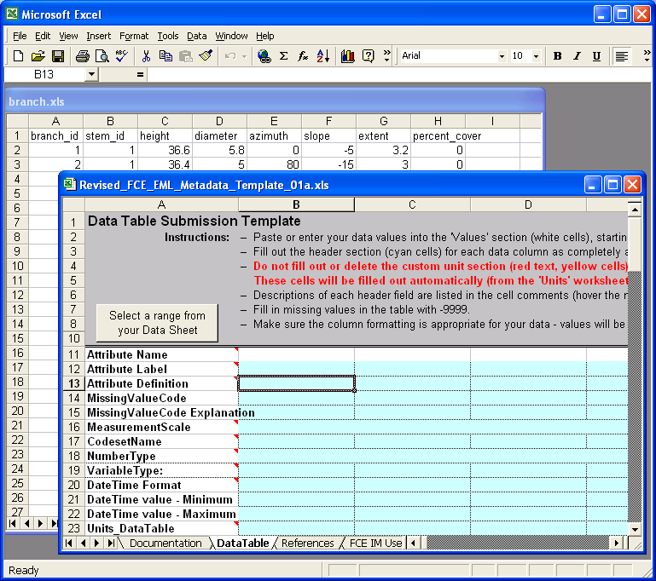

5. Click “Select a Range from your Data Sheet” button in the cell A7. It’ll open a small input form named “Select and Insert Data.”

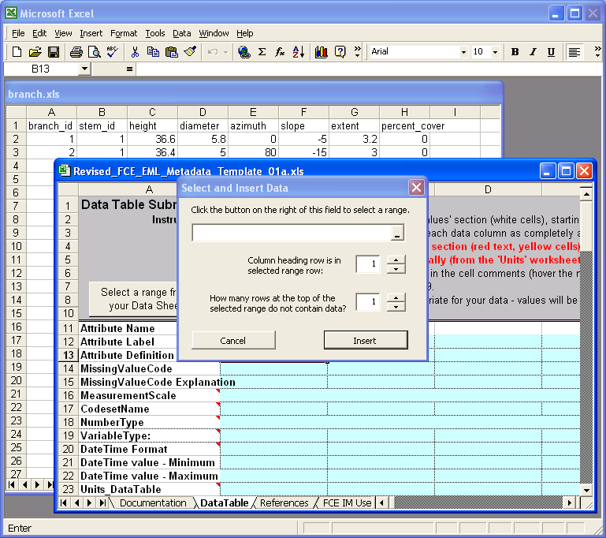

6. Click on the tiny button on the right side of the first input field in the form. It will open a small input field. Don’t enter anything here. This will be filled in as you select a range from the data sheet.

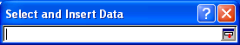

7. Move your mouse over to the branch.xls worksheet and click the worksheet.

8. Let’s say the data set for which metadata is being generated is on worksheet
“Book2” and in cells A1 through H21. To capture the attribute names and data onto the metadata.xls worksheet, click on the first field (A1) and drag your mouse to the end of the data (H21) and release the mouse button.

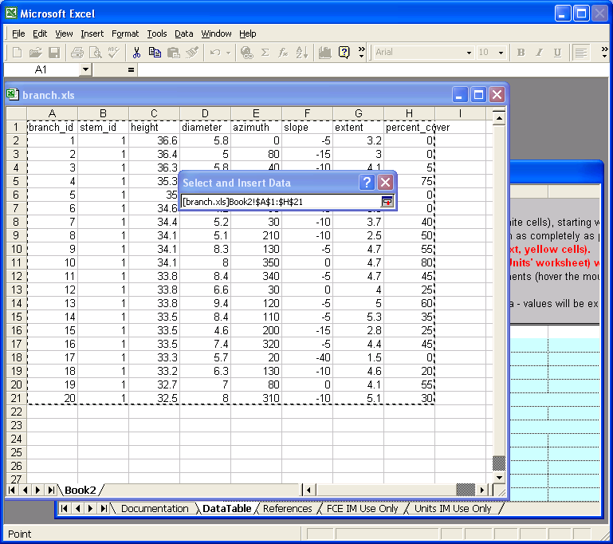

9. Press Enter key on your keyboard while you’re in branch.xls. It will display the selected range onto the selected range field in the input form.

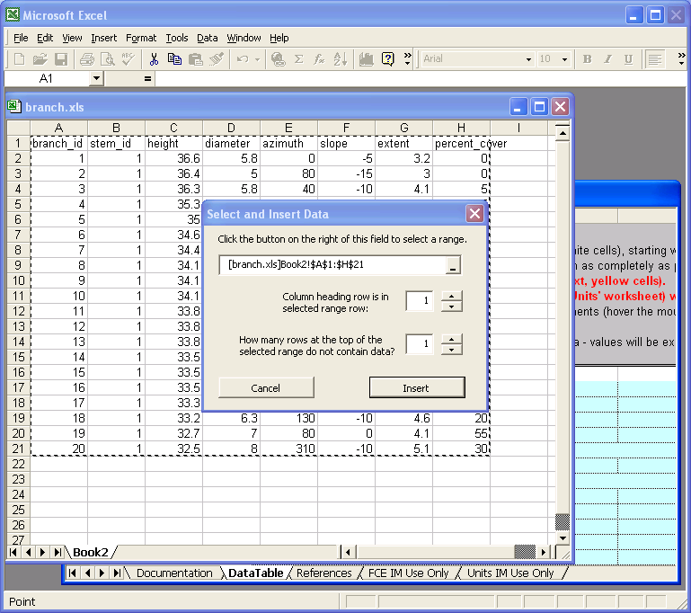

- Make sure the value of “Column heading row…” field is “1” - the column headings in branch.xls are in the first row of the selection.

- Make sure the value of“…do not contain data?” field is “1” - the first row in branch.xls is headings, not data.

- Click “Insert” button.

PLEASE NOTE:

If user pastes Data into worksheet at Column B, line 34, the data will be embedded into the EML (xml) document between the <dataset><distribution><inline> tags. If no data is pasted, the tags will NOT appear in EML (xml) document. Please note that the worksheet limitation in Excel is 65,536 rows by 256 columns so if the user has a larger dataset, it may be necessary to add the appropriate tags and data AFTER the EML (xml) document has been generated.
The program will embed data entered in the Values section of the DataTable worksheet into the EML file. If no values are entered in this section, no data will be embedded in the EML. If you plan to embed data, please validate document using EML 2.0.1 or higher.

VI. References Worksheet

The Long-Term Ecological Research Network (LTER) metadata is based on a metadata specification call Ecological Metadata Language (EML) Version 2.0.1 developed by the ecology discipline and for the ecology discipline, based on prior work done by the Ecological Society of America and associated efforts. EML is implemented as an XML schema that can be used to document ecological data. The following URL will provide in depth EML information including the EML 2.0.1 Specification, EML project information, and EML development information: http://knb.ecoinformatics.org/software/eml/.

*Original Excel Metadata Template created by Wade Sheldon, Information Manager, Georgia Coastal Ecosystems LTER and modified by Linda Powell (Information Manager) and Mike Rugge (Program Manager) Florida Coastal Everglades LTER (September, 2004). Contributors to this Excel metadata template include Linda Powell (FCE), Mike Rugge (FCE), Wade Sheldon (GCE), and Kristin Vanderbilt (SEV).

The LTER Core Research Areas are Primary Production,Trophic Structure, Organic Matter/Decomposition,Inorganic Fluxes,Disturbance,Data/Information Management,
Modeling/Synthesis and Regionalization.

VII. IM Use Only Worksheet

This worksheet contains 3 types of lists that are used in the DataTable and MethodsCitation worksheets. DO NOT DELETE any items within the list nor the entire IM Use Only worksheet.

VIII. Units IM Use Only Worksheet

This worksheet contains a listing of EML and Customs units used to populate Row 24 (Units) of the DataTable worksheet. You may add a custom unit to this worksheet and the addition will appear as a choice in the drop-down list on Row 24. Note: Make sure all the pertinent unit information is complete when adding a custom unit to the list. DO NOT DELETE any items within the list nor delete the entire Units IM Use Only worksheet.

Acknowledgements and References

The Long-Term Ecological Research Network (LTER) metadata is based on a metadata specification called Ecological Metadata Language (EML) Version 2.0.1 developed by the ecology discipline and for the ecology discipline, based on prior work done by the Ecological Society of America and associated efforts. EML is implemented as an XML schema that can be used to document ecological data. The following URL will provide in depth EML information including the EML 2.0.1 Specification, EML project information, and EML development information: http://knb.ecoinformatics.org/software/eml/

The original Excel Metadata Template created by Wade Sheldon, Information Manager, Georgia Coastal Ecosystems LTER and modified by Linda Powell (Information Manager) and Mike Rugge (Program Manager) Florida Coastal Everglades LTER (October, 2004).

Contributors to this Excel metadata template include:

- Linda Powell and Mike Rugge from Florida Coastal Everglades LTER Program (http://fcelter.fiu.edu) at the Florida International University.

- Wade Sheldon from Georgia Coastal Ecosystems LTER Program (http://gce-lter.marsci.uga.edu/lter/) at the University of Georgia.
- Kristin Vanderbilt from the Sevilleta Long-Term Ecological Research LTER Program (http://sevilleta.unm.edu) at the University of New Mexico.
- Youngmi Kim and Travis Brooks, programmers for the Canopy Database Project and graduates of The Evergreen State College Software Engineering Program (http://canopy.evergreen.edu/).
- Judy Bayard Cushing, Ph.D., a member of the Faculty (Computer Science), The Evergreen State College, Olympia, Washington and a principal investigator of the Canopy Database Project (http://academic.evergreen.edu/j/judyc/home.htm, http://canopy.evergreen.edu/).
Working in cooperation with the Evergreen State College contributors are Professor Barbara Bond, Department of Forest Science, Oregon State University and her students, Georgianne Moore, Texas A&M University and Kate George, USDA.

References

Cushing, J.B., N.M. Nadkarni, M. Finch, A.C.S. Fiala, E. Murphy-Hill, L. Delcambre, and D. Maier. In press. Component-based end-user database design for ecologists. Journal of Intelligent Systems.
Cushing, J.B., N.M. Nadkarni, B. Bond, and R. Dial. 2003. How trees and forests inform biodiversity and ecosystem informatics. Computing in Science & Engineering 5:32-43.

